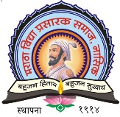 | MVP’S, K.P.G. ARTS, COMMERCE AND SCIENCE COLLEGE, IGATPURI  DEPARTMENT OF COMPUTER SCIENCE  ACADEMIC YEAR 2024-25  Best Practice

Department : Computer Science
Programme : College Online Service Centre
Location : KPG ACS College, Igatpuri
Organizer : Department of Computer Science
Date : Yearly
Beneficiary : 385

Mr. R.V. Nikam Mr. S.S. Pardeshi
Head, of the CS Dept. IQAC Coordinator

Dr. Kiran Rakibe
Principal

1) Title of the Practice: - “College Online Service Centre’’”
2) Objectives of the Practice: -
1) To help a tribal areas students by providing facility of Online Service to students in college under guidance of staff.
2) To increase the internet knowledge and allow them filling Merit Forms, Admission forms, and several others independently.
3) To give training to students for filling their various online forms.
3) The Context
MVP’s KPG Arts, Commerce and Science College is located in tribal area so around of college those students are staying they are not getting internet connectivity, mobile network & most of the students does not having smartphone.
In our college one computer lab with 22 PCS & Connected with 300MBPS internet broadband. This labs gives facility to students to fill their online form in off time when lab is free under the guidance of concern faculty teacher. We utilize our resources maximum it helps our tribal area students.
Our college has form committee, teachers has well trained by computer science department. The trainee teachers has guide to other students.
- Our Online Form Filling Centre journey starts when students come in college by filling online merit form & admission form under the guidance of teachers.
- After taking admission our most of students from reserve category so our centre helps students filling there Scholarship Form, EBC Form & Hostel form and solves there query occurs while filling form.
- To help students for filling Online Examination Form, Migration Form and Convocation Certificate Form of SPPU.
- Our Centre helps the students while filling Competitive Examination Form & various CET forms.
- Our Centre provides information how to make resume under guidance of teachers.

4) The Practice: Every year as per students’ need.

5) Evidences of Success:-
1) Students learnt to fill the forms, and they guided other students too.
2) Students became aware of online form filling; now they are exposed to online processes.
3) It has been helpful to students from economically backward situation.
6) Problems Encountered and Resource Required
1) Sometimes when internet fiber break the line so getting network problem.
2) Not having sufficient requirement of Computers, printers and scanner.

Mr.C. D. Chaudhari Mr. S.S. Pardeshi
Head, of the CS Dept. IQAC Coordinator
Dr. Kiran Rakibe
Principal
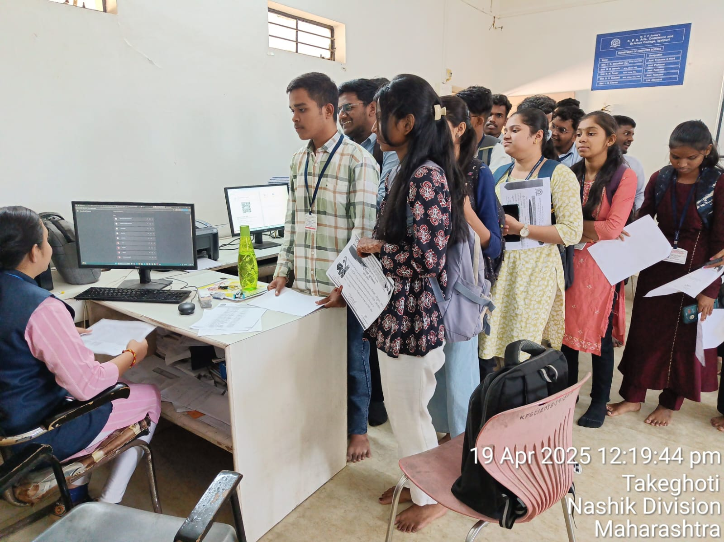

Online Form Filling

