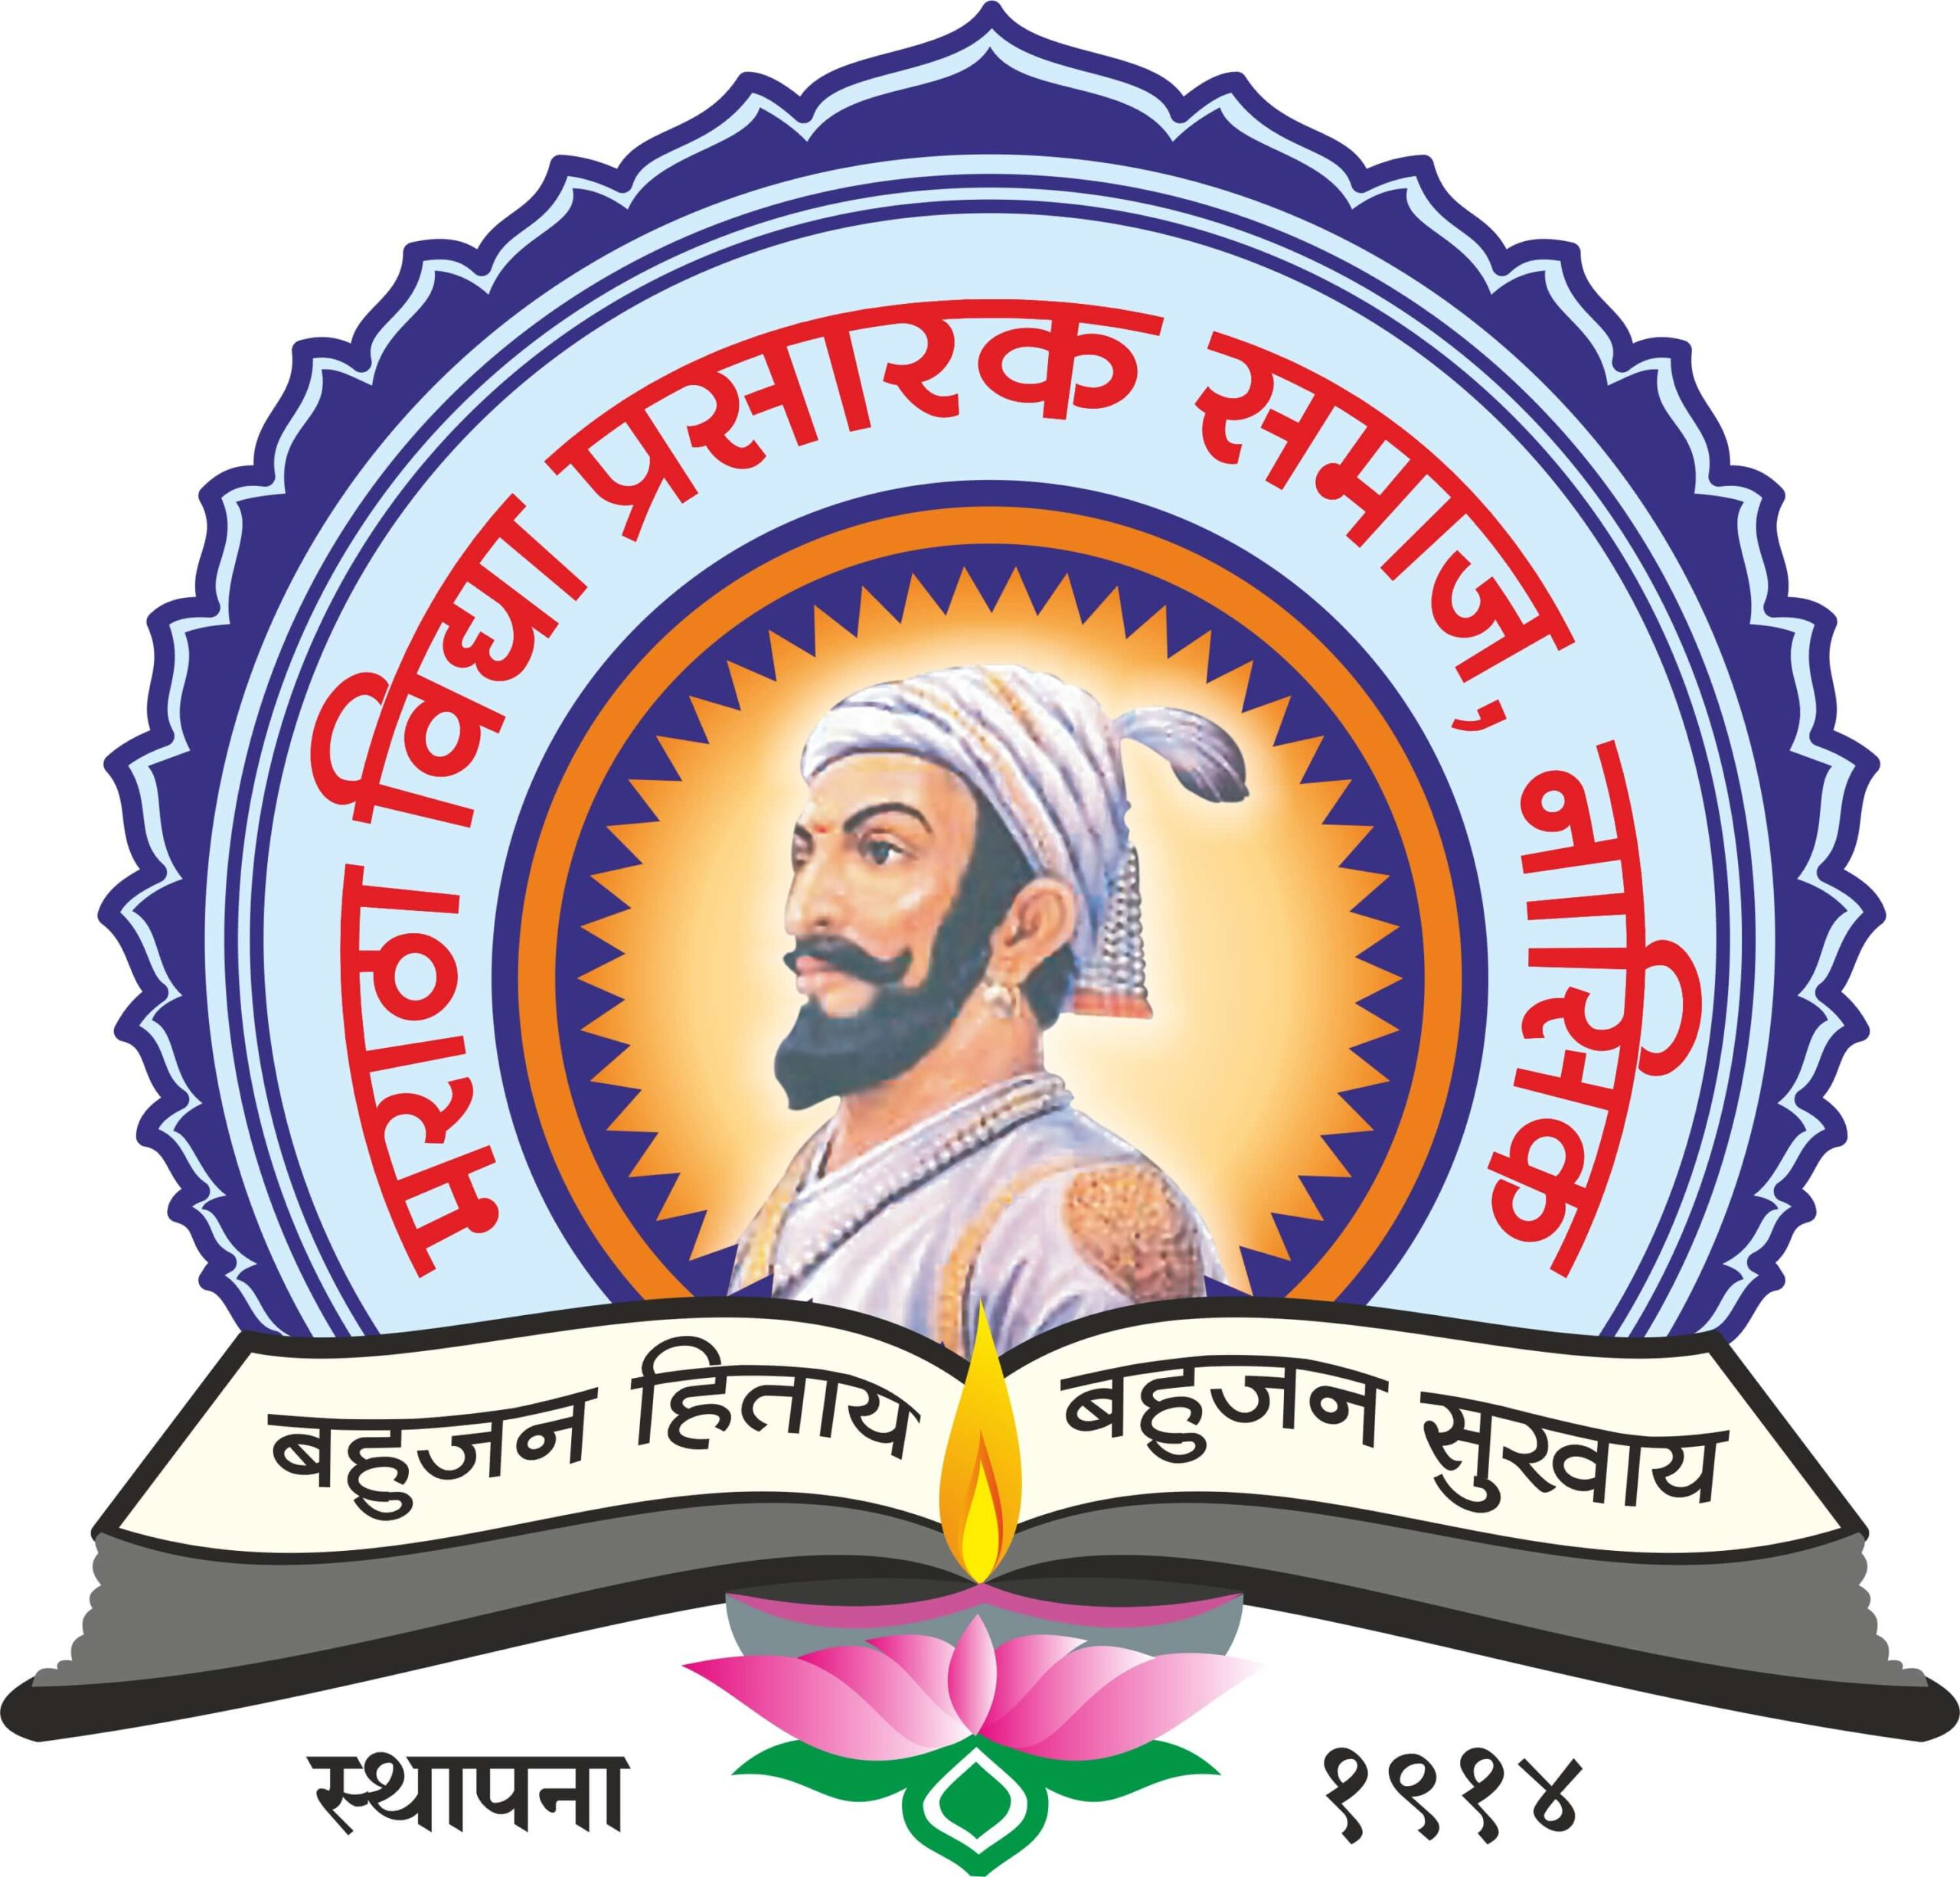

K.P.G Arts, Commerce & Science College, Igatpuri

Department of Computer Science

ATTAINMENTS: B.Sc. Computer Science

SN | Class | Semester | Subject With Code | Course Outcome | Attainments
1 | F.Y. B.Sc. (CS)  NEP | First | Problem Solving using Computer and ‘C’ Programming  CS-101-T | • To understand the concept of Problem solving  • To understand steps involved in algorithm & program development  • To understand the concept of Algorithm  • Develop Algorithm for simple problem  • Ability to implement algorithms in the ‘C’ language.  • Develop modular programs using control structures and arrays in ‘C’. | - Students are able to solve problem logically.  - Able to identify the steps involved in algorithm /program development.  - Able to understand the concept of algorithm  - Able to develop Algorithm for simple problem.  - Able to implement algorithms in the ‘C’ language.  - Students logical ability is build and able to develop modular programs.
2 | F.Y. B.Sc. (CS)  NEP | First | Practical course based on CS101  CS-101-P | • Able to devise pseudo code and flowchart for computational problems.  • Understand how to write, debug and execute simple programs in C. | - Students are able to devise pseudo code and flowchart for computational problems.  - Understand how to write, debug and execute simple programs in C.
4 | F.Y. B.Sc. (CS)  NEP | Second | Advanced ‘C’ Programming  CS-151-T | • Develop advanced concepts of programming using C.  • Develop modular programs using control structures, pointers, arrays, strings and structures.  • Design and develop solutions to real world problems using C.  • To develop structured programming approach. | - Student logical ability is build & seen that they are able to develop C programs.  - Able to use structures to develop modular programs.  - Able to design and develop solutions to real world problems using C.  - Able to develop structured programming approach
5 | F.Y. B.Sc. (CS)  NEP | Second | CS-151-P  Practical | • Write debug and execute programs using advanced features in C. | - Students are able to debug & execute programs of Advanced C
7 | S.Y.  B.Sc.  (CS) | Third | Data Structures and Algorithms – I  CS 231 | • Understand different methods of organizing large amount of data using data structure.  • Able to choose appropriate data structure as applied to specified problem definition.  • Understand various techniques for representation of the data in the real world | - Students are able to understand different methods of organizing large amount of data using data structure.  - Able to choose appropriate data structure as applied to specified problem definition.  - Able to understand various techniques for representation of the data in the real world
8 | S.Y.  B.Sc.  (CS) | Third | Software Engineering  CS 232 | • To design and conduct experiments, as well as to analyze and interpret data.  • To identify, formulate, and solve engineering problems.  • To analyze, design, verify, validate, implement, apply, and maintain software systems.  • Able to understand different phases of SDLC. | - Able to design and conduct experiments, as well as to analyze and interpret data.  - Able to identify, formulate, and solve engineering problems.  - Able to analyze, design, verify, validate, implement, apply, and maintain software systems.  - Able to understand different phases of SDLC.
9 | S.Y.  B.Sc.  (CS) | Third | Practical course on CS 231 and CS 232  CS 233 | • Students will be able to use linear and non-linear data structures like stacks, queues, linked list etc.  • Student will be able to handle operations like searching, insertion, deletion, traversing mechanism etc. on various data structures. | - Student are able to solve assignment of Data structure program on array, linked list, stack, and queue.  - Able to handle operations like searching, insertion, deletion, traversing mechanism etc. on various data structures.
10 | S.Y.  B.Sc.  (CS) | Fourth | Data Structures and Algorithms – II  CS 241 | - To compute the complexity of various algorithms.  - To understand structure of tress, graphs, etc.  - To develop efficient search techniques. | - Able to compute the complexity of various algorithms.  - Able to understand structure of tress, graphs, etc.  - Able to develop efficient search techniques.
11 | S.Y.  B.Sc.  (CS) | Fourth | Computer Networks – I  CS 242 | • Understand basic computer network technology.  • Understand and explain Data Communications System and its components.  • Able to identify the different types of network topologies and protocols.  • Enumerate the layers of the OSI model and TCP/IP. Explain the function(s) of each layer. | - Able to understand basic computer network technology.  - Able to understand and explain Data Communications System and its components.  - Able to identify the different types of network topologies and protocols.  - Able to enumerate the layers of the OSI model and TCP/IP and function(s) of each layer.
12 | S.Y.  B.Sc.  (CS) | Fourth | Practical course on CS 241 and CS 242  CS 243 | - Students will be able to use linear and non-linear data structures like stacks, queues, linked list etc.  • Student will be able to handle operations like searching, insertion, deletion, traversing mechanism etc. on various data structures. | - Students will be able to use linear and non-linear data structures like stacks, queues, linked list etc.  - Student will be able to handle operations like searching, insertion, deletion, traversing mechanism etc. on various data structures.  - Student are able to solve assignment of Data structure & software engineering mini project.
13 | T.Y.  B.Sc.  (CS) | Fifth | Operating Systems  CS-351 | - To Study Processes and Thread Scheduling by operating system  - Synchronization in process and threads by operating system  - Memory management by operating system using with the help of various schemes | - Understand processes and thread Scheduling by operating system  - Understand Synchronization in process and threads by operating system  - Understand Memory management by operating system using with the help of various schemes
14 | T.Y.  B.Sc.  (CS) | Fifth | Computer Networks – II  CS-352 | - To understand the different protocols of Application layer.  - Develop understanding of technical aspect of Multimedia Systems  - Develop various Multimedia Systems applicable in real time.  - Identify information security goals.  - Understand, compare and apply cryptographic techniques for data security. | - Student will understand the different protocols of Application layer.  - Develop understanding of technical aspect of Multimedia Systems  - Develop various Multimedia Systems applicable in real time.  - Identify information security goals.  - Understand, compare and apply cryptographic techniques for data security.
15 | T.Y.  B.Sc.  (CS) | Fifth | Web Technologies – I  CS-353 | - To study basics of PHP  - To design logical code with std, PHP functions  - To understand how to develop dynamic and interactive Web Page | - Understand the concepts of PHP  - Design logical code with std, PHP functions  - Understand how to develop dynamic and interactive Web Page
16 | T.Y.  B.Sc.  (CS) | Fifth | Foundations of Data Science  CS-354 | - Perform Exploratory Data Analysis  - Obtain, clean/process, and transform data.  - Detect and diagnose common data issues, such as missing values, special values, outliers, inconsistencies, and localization.  - Demonstrate proficiency with statistical analysis of data.  - Present results using data visualization techniques.  - Prepare data for use with a variety of statistical methods and models and recognize how the quality of the data and the means of data collection may affect conclusions | - Able to perform Exploratory Data Analysis.  - Able to obtain, clean/process, and transform data.  - Detect and diagnose common data issues, such as missing values, special values, outliers, inconsistencies, and localization.  - Demonstrate proficiency with statistical analysis of data.  - Present results using data visualization techniques.  - Prepare data for use with a variety of statistical methods and models and recognize how the quality of the data and the means of data collection may affect conclusions
17 | T.Y.  B.Sc.  (CS) | Fifth | Object Oriented Programming using Java – I  CS-355 | - To understand the concept of classes, object, packages and Collections.  - To develop GUI based application | - Understand the concept of classes, object, packages and Collections.  - Student are able to solve GUI based application
18 | T.Y.  B.Sc.  (CS) | Fifth | Theoretical Computer Science  CS-356 | On completion of the course, student will be able to–  ● To understand the use of automata during language design.  ● Relate various automata and Languages. | - Understand the use of automata during language design.  - Relate various automata and Languages.
19 | T.Y.  B.Sc.  (CS) | Fifth | Practical Course based on CS - 351  CS-357 | - To study Process synchronization  - Processes and Thread Scheduling by operating system  - Memory management by operating system using with the help of various schemes | - Understand Process synchronization  - Processes and Thread Scheduling by operating system  - Memory management by operating system using with the help of various schemes
20 | T.Y.  B.Sc.  (CS) | Fifth | Practical Course based on CS - 353 and CS – 354  CS-358 | - To study how to develop dynamic and interactive Web Page  - To prepare data for use with a variety of statistical methods and recognize how the quality of the data may affect conclusions.  - To perform exploratory data analysis | - Understand how to develop dynamic and interactive Web Page  - Prepare data for use with a variety of statistical methods and recognize how the quality of the data may affect conclusions.  - Perform exploratory data analysis
21 | T.Y.  B.Sc.  (CS) | Fifth | Practical Course based on CS – 355  CS - 359 | - Use an integrated development environment to write, compile, run, and test simple  - To develop object-oriented Java programs.  - Read and make elementary modifications to Java programs that solve real-world problems.  - Validate input in a Java program. | - Use an integrated development environment to write, compile, run, and test simple  - Able to develop object-oriented Java programs.  - Read and make elementary modifications to Java programs that solve real-world problems.  - Validate input in a Java program.
22 | T.Y.  B.Sc.  (CS) | Fifth | Python Programming  CS-3510 | - To develop logic for problem solving using python.  - To determine the methods to create and develop Python programs by utilizing the data  Structures like lists, dictionaries, tuples and sets.  - To be familiar about the basic constructs of programming such as data, operations, conditions, loops, functions etc.  - To write python programs and develop a small application project | - Able to develop logic for problem solving using python.  - Determine the methods to create and develop Python programs by utilizing the data  - Structures like lists, dictionaries, tuples and sets.  - To be familiar about the basic constructs of programming such as data, operations, conditions, loops, functions etc.  - Able to write python programs and develop a small application project
23 | T.Y.  B.Sc.  (CS) | Fifth | Block chain Technology  CS-3511 | On completion of the course, student will be able to–  - Learn the fundamentals of Block chain Technology.  - Learn Block chain programming  - Basic knowledge of Smart Contracts and how they function. | - Understand the fundamentals of Block chain Technology.  - Learn Block chain programming  - Basic knowledge of Smart Contracts and how they function  - Student are able to understand concept of crypto-currency e.g.: bit coin.
24 | T.Y.  B.Sc.  (CS) | Sixth | Operating Systems-II  CS - 361 | - To study management of deadlocks and File System by operating system  - Scheduling storage or disk for processes  - Distributed Operating System and its architecture and the extended features in mobile OS. | - Understand management of deadlocks and File System by operating system.  - Understand scheduling storage or disk for processes  - Understand Distributed Operating System and its architecture and the extended features in mobile OS.
25 | T.Y.  B.Sc.  (CS) | Sixth | Software Testing  CS-362 | - Understand various software testing methods and strategies.  - Understand a variety of software metrics, and identify defects and managing those defects for improvement in quality for given software.  - Understand design test cases and test plans, review reports of testing for qualitative software.  - Understand latest testing methods used in the software industries. | - To understand various software testing methods and strategies.  - To understand a variety of software metrics, and identify defects and managing those defects for improvement in quality for given software.  - To design test cases and test plans, review reports of testing for qualitative software.  - To understand latest testing methods used in the software industries.
26 | T.Y.  B.Sc.  (CS) | Sixth | Web Technologies – II  CS - 363 | On completion of the course, student will be able to–  • Build dynamic website.  • Using MVC based framework easy to design and handling the errors in dynamic website. | - Able to build dynamic website.  - Able to use MVC based framework easy to design and handling the errors in dynamic website
27 | T.Y.  B.Sc.  (CS) | Sixth | Data Analytics  CS - 364 | - Use appropriate models of analysis, assess the quality of input, and derive insight from results.  - Analyze data, choose relevant models and algorithms for respective applications  - Understand different data mining techniques like classification, prediction, clustering and association rule mining  - Apply modeling and data analysis techniques to the solution of real world business problem | - logical ability is build & seen that they are able Analyze data,  - Able to choose relevant models and algorithms for respective applications.  - Able to understand different data mining techniques like classification, prediction, clustering and association rule mining.  - Able to apply modeling and data analysis techniques to the solution of real world business problem
28 | T.Y.  B.Sc.  (CS) | Sixth | Object Oriented Programming using Java – II  CS- 365 | - To access open database through Java programs using Java Data Base Connectivity (JDBC) and develop the application.  - Understand and create dynamic web pages, using Servlets and JSP.  - Work with basics of framework to develop secure web applications. | - Able to access open database through Java programs using Java Data Base Connectivity (JDBC) and develop the application.  - Able to create dynamic web pages, using Servlets and JSP.  - Able to Work with basics of framework to develop secure web applications.
29 | T.Y.  B.Sc.  (CS) | Sixth | Compiler Construction  CS-366 | - To understand the process of scanning and parsing of source code.  - Learn the conversion code written in source language to machine language.  - To study tools like LEX and YACC. | - Able to understand the process of scanning and parsing of source code.  - Able to learn the conversion code written in source language to machine language.  - Understand tools like LEX and YACC.
30 | T.Y.  B.Sc.  (CS) | Sixth | Practical Course based on CS – 361  CS-367 | - Management of deadlocks by operating system  - File System management  - Disk space management and scheduling for processes | - Able to do management of deadlocks by operating system  - Understand file system management  - Understand Disk space management and scheduling for processes.
31 | T.Y.  B.Sc.  (CS) | Sixth | Practical Course based on CS - 363 and CS – 364  CS - 368 | - Build dynamic website.  - Using MVC based framework easy to design and handling the errors in dynamic website | - Build dynamic website.  - Using MVC based framework easy to design and handling the errors in dynamic website
32 | T.Y.  B.Sc.  (CS) | Sixth | Practical Course based on CS – 365  CS - 369 | - To Learn database Programming using Java  - Understand and create dynamic web pages using Servlets and JSP.  - Work with basics of framework to develop secure web applications | - To Learn database Programming using Java  - Understand and create dynamic web pages using Servlets and JSP.  - Work with basics of framework to develop secure web applications
33 | T.Y.  B.Sc.  (CS) | Sixth | Software Testing Tools  CS - 3610 | - To understand various software testing methods and strategies.  - To understand a variety of software metrics and identify defects and managing those defects for improvement in quality for given software.  - To design test cases and test plans, review reports of testing for qualitative software.  - To understand latest testing tools used in the software industries. | - Able to understand various software testing methods and strategies.  - Able to understand a variety of software metrics and identify defects and managing those defects for improvement in quality for given software.  - Able to design test cases and test plans, review reports of testing for qualitative software.  - Understand latest testing tools used in the software industries.
34 | T.Y.  B.Sc.  (CS) | Sixth | Project  CS - 3611 | - Project Planning, design, coding  - Test Plan, Black Box Testing or Data Validation Test Cases.  - White Box Testing or Functional Validation Test cases and results | - Logical ability is build & they are create project in different languages like JAVA, PHP using database like MYSQL, PostgreSQL.  - Able to use different Testing like White box, Black Box also used different environment framework like Net Beans, Eclipse, etc.

Mr. R.V. Nikam Mr. S.S. Pardeshi Dr. Kiran Rakibe
Head of the CS Dept. IQAC Coordinator Principal

