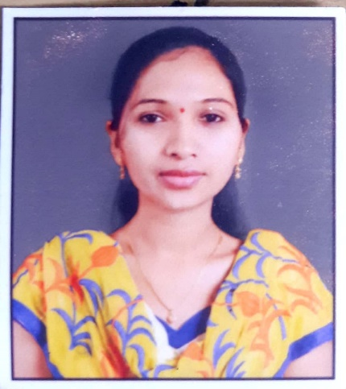

Individual Profile
- Name : Mrs. Pooja Haribhau Jadhav.
- Designation : Assistant Professor in Commerce
- Qualification : M. Com, SET, M.A (Eco), G.D.C. & A., Ph.D.(Pursuing)
- Date of Birth : 17th March 1995
- Date of Joining (Institution) : 8th August 2021
- Teaching Experience : 06 Year UG Level, 04 Year PG Level.

- Educational Qualification-

Degree | Subject | University | Year
Ph. D. | Marketing | SPPU | Pursuing
SET | Commerce | SPPU | 2019
M. Com. | Commerce | SPPU | 2018
M.A. | Economics | SPPU | 2020
B.Com. | Commerce | SPPU | 2016
G. D. C. & A. | Co-operation | Cooperation& Accountancy Board Maharashtra. | 2017

- Teaching Experience: UG and PG Level.
  - K.K. Wagh Arts, Commerce, Science & Computer Science College, Kakasaheb Nagar, Ranwad. Nashik from 16/08/2018 to 30/04/2021.
  - MVPs Arts & Commerce College, Khedgoan, Nashik from 08/08/2021 to 03/12/2021.
  - MVPs KGDM Arts, Commerce & Science College, Niphad from 03/12/2021 to
19/06/2023.
  - MVP, s Arts, Commerce & Science College, Nandgaon from 20/06/2023 to 30/04/2025.

Area of Interest - Business Administration, Marketing, Accountancy, Taxation, Costing, Finance, Economics.

Academic Staff College Orientation/Refresher Course /Workshop/Conference/Seminars attended
Sr. no. | Type | Name of the College | Subject | Year
1 | Workshop | K. K. Wagh Education Society,Nashik | Online International Ganesha Idol Making | 2020
2 | Workshop | K.K.Wagh Education Society  K. K. Wagh College of Pharmacy, Nashik  K. K. Wagh Institute of Pharmacy, Chandori | Novel ICT Tools for Teaching Learning | 2020
3 | Workshop | K.K.Wagh Education Society  K. K. Wagh Arts, Commerce, Science & Computer  Science College, Bhausahebnagar, Niphad | Need of Effective Communication Skills | 2020
4 | Workshop | K.K.Wagh Education Society  K. K. Wagh Arts, Commerce, Science & Computer  Science College, Bhausahebnagar, Niphad | AtmanirbharBhrarat: Past, Present &Future. | 2020
5 | National Webinar | K. K. Wagh Arts, Commerce, Science & Computer  Science College Nashik | Online Teaching Learning and Online Accreditation | 2020
6 | Certificate Course | District Sports Office Nashik  K. S. K. W. College, Nashik & Yogic Science Association Nashik. | Basic Yoga Certificate Course | 2021
7 | National Seminar | Indian School of Political Economy, Pune. | Three Decades of Reform: Present Issue & Future Challenges | 2021
8 | Workshop | Poona College of Arts, Science and Commerce, Pune. | Research Methodology | 2022
9 | Workshop | Maratha Vidhya Prasarak Samaj’s  Human Resource Development Center, Nashik | Work Skills and Prosocial Behavioral Development for Senior and Professional College Teacher | 2023
10 | National Conference | Sangmner Nagarpalika Arts,s D. J. Malpani Commerce and B. N. Sarda Science College (Autonomous) Sangmaner . | Change and Transformation in Commerce and Management:Breakthrough Innovation and Creativity. | Nov 2023
11 | National web seminar | Gokhale Education Society,Shree Bhausaheb Vartak Arts, Commerce and Science College, Boriwali(W) Mumbai - 91 | Changing landscape of service sector in today’s business environment | 13thApril 2024
12 | Workshop | Maratha Vidhya Prasarak Samaj’s G.M.D. Art’s, B.W.Commerce and science college sinner, Nashik | Implementation of National Education Policy - 2020 | 29th April 2024
13 | Workshop | Maratha Vidhya Prasarak Samaj’s Art’s, Commerce and science college Manmad, Nashik | Implementation of National Education Policy - 2020 | 3rd July 2024
14 | International Conference | RTC B.Ed. College, P.H.E.D., Buti, Ranchi (Zarkhand) | Multidisciplinary Research in Education, Entrepreneurship, Employment and Economic Development | 23-24 November 2024
15 | Vyklhyanmala on savitribai phule | Mata savitribai phule shodh peeth, | Women Education in India and Development | 04th January 2025
 | International Webinar | MGV’s Mahilaratn Pushpatai Hiray Arts, Science and Commerce Mahila Mahavidyalay, Malegoan Camp | Health and Fitness for Women | 07th January 2025
16 | FDP /Orientation Program | UGC Malviy Mission Teacher Training Center, Mizoram University. | 21st NEP Orientation and Sensitization Programme | 13th January to 21st January 2025
17 | National Multidisciplinary Web Conference | Gokhale Education Society, Shree Bhausaheb Vartak Arts, Commerce and Science College, Boriwali(W) Mumbai - 91 | Viksit Bharat @2047 : Pathways to Develop an Inclusive Nation | 24th February 2025
18 | Workshop | Modern Education Society  Ness Wadia Commerce College, Pune | Syllabus Restructuring of S.Y.B.COM (Business Administration) as per NEP 2020 | 12th June 2025

  - Co-Curricular Activity:
Attended several UG and PG ‘Central Assessment Programme’ of Savitribai Phule Pune University during last 6 years
  - Extra-Curricular Activity:
Active participation in organizing various activity in the college.

